Sawdust Park & Ride
701 Westridge Rd., Spring, TX
Have questions about the schedule? Call (281) 363-0882
Feel like you have missed a bus? Need assistance while riding? Call (832) 851-3362
Sign up for Transit Alerts & Newsletter @ https://www.thewoodlandstownship-tx.gov/ALERTS
AM Schedule
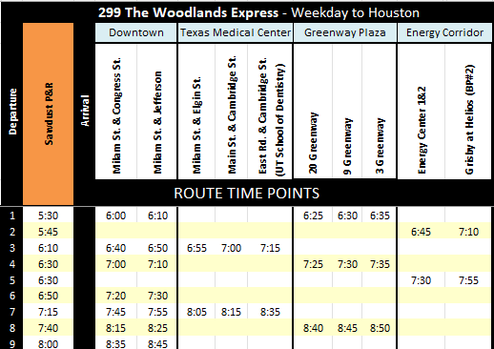
SAWDUST SCHEDULE
PM Schedule
